Spring 2021 - CCM ID Photo

Faculty & Staff
All employees will be required to wear a college-issued identification badge. The badge should be worn above the waist, with the front facing forward. CCM identification badges can be obtained from the Office of Campus Life virtually following these instructions.
You can easily submit the photo you would like included on your CCM ID.
After your photo has been approved, the image will be added to your CCM ID and printed. When your CCM ID is ready to be picked up on campus, you will receive an email from campuslife@ccm.edu with instructions for picking up your CCM ID and your Parking Permit.
Please Note: Be sure to review the criteria and directions outlined below before submitting your photo.
Photo submission requirements:
- Recent color photo
- Plain, white background
- Bright, even lighting
- Centered, frontal view of full face – no profile
- Cropped from just above the top of the head to the collarbone
- Eyes open and visible (wear prescription glasses if you normally do so)
Acceptable Photo Example:
Unacceptable Photo
- Hats, sunglasses or other items that obscure your face
- Glare on glasses, shadow
- Other visible people or objects in the photo
- Inappropriate expressions or gestures
- Professional photos, senior portraits or school photos
- Photos of photos
Unacceptable Photo Example:
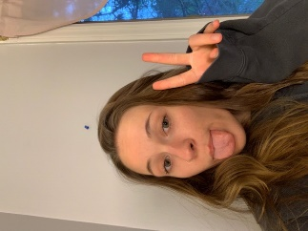
How to Submit Your Photo
- You can submit your photo with a smartphone, tablet or a computer.
- Log in to your CCM Email Account (Help logging in)
- Take a photo using your device or upload an existing photo (must be .jpeg, .png., or .gif file)
- Submit photo by attaching it to an email with the subject line: Photo, to the Office of Campus Life: campuslife@ccm.edu
- You will be notified via email if your photo has been accepted or rejected.
New or Replacement CCM ID Cards
When your CCM ID is ready to be picked up on campus, you will receive an email from campuslife@ccm.edu with instructions for picking up your CCM ID and your Parking Permit.
Returning Adjunct Validation Stickers
Validation stickers will not be distributed during the spring semester.
Questions: Contact Campus Life at campuslife@ccm.edu or 973-328-5225.

