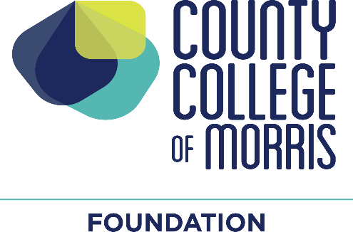

**Louise and Samuel Olshan Endowment for Faculty Professional Development**

**Purpose**

The fund will provide financial support to full-time faculty members (not including chairs or assistant chairs) and adjunct faculty who have taught 20 semesters (fall and/or spring) in the last 12 years. Grants will defray the cost of membership in professional organizations or to attend conferences or professional meetings.

1. For membership in a professional organization the maximum award will be $50.
2. For attendance at an in-state professional organization meeting, the maximum funding will be $75 to be used for registration, travel and lodging.
3. For attendance at an out-of-state professional organization meeting, the maximum funding will be $150, to be used for registration, travel and lodging.
4. Preference may be given to applicants who have not received professional development funding, including Olshan Endowment funding, in the past three (3) years.
5. Applicants who are requesting Olshan Endowment funding to supplement other funds for professional development activity may be considered.
6. Applications must be submitted by November 1 for December 1 decision, and by May 1 for June 1 decision.
7. Applicants may request support *in advance* of a conference or membership, or as *reimbursement* fora conference attended.

**Committee**

The decision-making committee will consist of:

* The Vice President of Academic Affairs, Workforce Development and Student Success
* A faculty member in the School of Business, Mathematics, Engineering and Technology, to be chosen by the Dean of that school
* A faculty member in the School of Health and Natural Sciences, to be chosen by the Dean of that school
* A faculty member in the School of Liberal Arts, to be chosen by the Dean of that school
* The Co-Directors for the Center for Teaching and Learning (CTL)

The Vice President of Academic Affairs, Workforce Development and Student Success will convene the committee.

**Terms of Office**

The Vice President of Academic Affairs, Workforce Development and Student Success and the Co-Directors for the Center for Teaching and Learning are standing members of the Committee. Initially, two faculty members will be selected for two (2) year terms. One faculty member will be selected for a one (1) year term. When that 1-year term ends, that faculty member (or a replacement) will be selected for a two-year term. The purpose is to assure that all three faculty members do not serve concurrently.